We Provide a Unique Market Research, Website Useability Compliance Audit and Free Traffic & Ranking Revolution Service like no other.

Our Audit provide detail report on:

* How well does your school web presence rank on Google?
* Does the website use optimization effectively?

If not, we will help optimise your Google profile professionally, help you reach the top of search engine, maximize your online presence, help you attract more customers, and engage with your existing customers through a steady flow of reviews.

When You Sign Up for This Service today, you will be able to achieve The Following:

# Rank Higher on Google

**A Google My Business management service that gets your listing to the top of the search results**



Improved visibility and **rank higher in customer searches**

Outrank competitors

Get more **positive reviews and comments** on your business profile

50% of prospects more likely to **lead to enrolment**

2.7x more likely to be **considered reputable**

70% more likely to **attract a location visit**

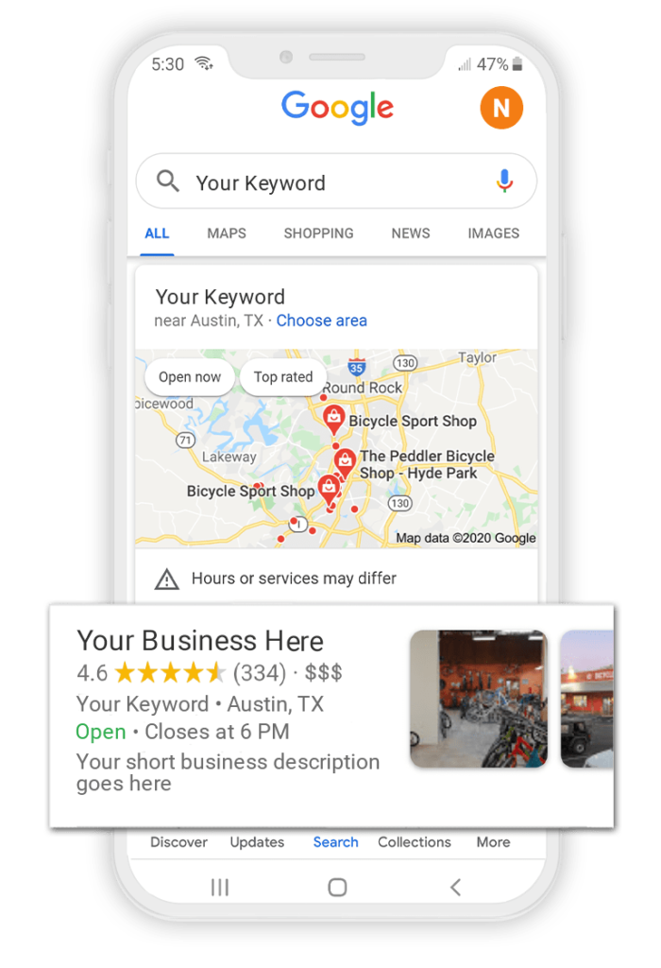

**Are You Struggling with Google My Business?**

* Sick of not seeing your school show up on Google?
* Confused by how to get your school listed on Google?
* Worried you’re missing out on ways to promote your school?
* Concerned you don’t have the time or knowledge to succeed?
* Disappointed with the results from agencies and consultants?
* Tired of not getting enough new enrolments from your efforts?

If you are struggling with Google My Profile management or are having difficulty juggling multiple profiles, we can help.

We have experience working with private schools spanning over 15 years.

Let our Google My Profile management service put you on the top of map today!

## 

**Ensure a Positive Reputation on Google**

**Easily get new Google reviews and never have to worry about responding**

Reviews are one thing every customer wants to read before making a purchase decision. Google agrees. Industry studies show that Google reviews are an important factor in ranking your listing on Google Maps and the local pack.

Thanks to the School Support Centre, you will no longer need to awkwardly ask customers for reviews and then forget to respond to them – we do it for you!

## Our Web Presence Management Service

***Eliminate frustration. Spend less time. Get more results.***

#### Create

We start by creating (or claiming) your Google My Profile and helping you through the verification process.





#### Optimize & Posts

We will then get to work transforming your Google My Profile into an optimized revenue machine. We create Google My Profile Posts to promote what you’re doing. Our team designs each image, writes the contents, and we even post it for you!



#### Monitor & Reviews

We continually monitor and manage your profile every month for new Q&A, reviews, and edits Posts. We help you generate new reviews and will respond to new reviews left on your profile.



#### Expertise

We assign you a dedicated account manager who is a Google My Business expert and ensures best results and prompt respond to new questions and manage answers to existing questions to ensure accuracy.

PRICE: ~~N99, 950.00~~ SAVE 50.01% N49,950.00 per term



Buy Membership Bundle